PROJECT REPORT OF INDUSTRY ORIENTED HANDS ON EXPERIENCE (IOHE)
ON
Blockchain Forensics for Pig Butchering Scams
submitted in partial fulfilment of the requirements for the award of degree of

BACHELOR OF ENGINEERING
In
COMPUTER SCIENCE AND ENGINEERING

Submitted by: Supervised By:
Pratham Chhetri Dr. Gurpreet Singh
2210992075 Associate Professor and Placement Incharge
Chitkara University


DEPARTMENT OF COMPUTER SCIENCE AND ENGINEERING

CHITKARA UNIVERSITY INSTITUTE OF ENGINEERING AND TECHNOLOGY
CHITKARA UNIVERSITY, PUNJAB, INDIA

CONTENTS

S.No. | Title | Page No.
 | Acknowledgement | 3
 | List of Figures and Tables | 4
 | Abstract | 5
1 | Introduction | 6
2 | Methodology | 7
3 | Tools and Technologies | 8
4 | Implementation | 9
5 | Major Findings/Outcomes/Output/Results | 10
6 | Conclusion and Future Scope | 11
 | References | 12
 | Appendices | 14

ACKNOWLEDGEMENT

I would like to express my sincere and profound gratitude to my mentor, Dr. Gurpreet Singh, for his continuous guidance, unwavering support, and consistent encouragement throughout the development of this project. His extensive knowledge, critical insights, and constructive feedback played a pivotal role in shaping the direction and quality of this research. His ability to clarify complex concepts and provide practical perspectives greatly enhanced my understanding of blockchain forensics and machine learning. I am especially thankful for his patience, timely suggestions, and motivation, which enabled me to overcome challenges and maintain a disciplined approach toward achieving the objectives of this study.

I would also like to extend my sincere appreciation to the Department of Computer Science and Engineering, Chitkara University, for providing a highly supportive academic environment and the necessary infrastructure required to carry out this research effectively. The availability of technical resources, research facilities, and a collaborative learning atmosphere significantly contributed to the successful execution of this project. Furthermore, the department’s emphasis on innovation, research excellence, and practical learning has been instrumental in helping me develop both technical competence and analytical thinking skills, which were essential for completing this work.
.

List of Figures and Tables

- Flow Chart –

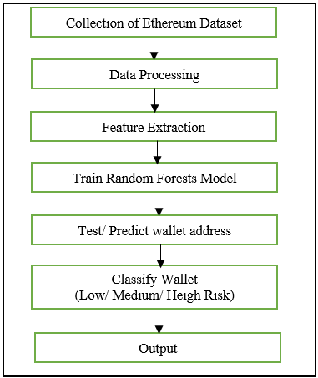

- Performance Evaluation of Model
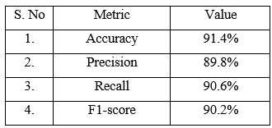

Abstract

Digital financial crimes involving cryptocurrency have increased significantly in recent years, with pig butchering scams emerging as a common fraud method. These scams rely on social engineering techniques to gain the trust of victims and convince them to transfer funds to fraudulent wallet addresses. Due to the pseudo-anonymous nature of blockchain transactions, detecting such fraudulent activities is a challenging task.
This project proposes a machine learning-based blockchain forensic framework to identify suspicious Ethereum wallet addresses associated with pig butchering scams. The system uses transaction data collected in CSV format, which is preprocessed to remove inconsistencies and missing values. Important behavioral features such as transaction count, total value, unique connections, and transaction frequency are extracted.
A Random Forest classifier is used to analyze these features and classify wallet addresses into risk categories such as low, medium, and high risk. The model achieves an accuracy of 91.4%, demonstrating its effectiveness in detecting suspicious transaction patterns.
This framework helps investigators automate the detection process and enhances blockchain-based fraud analysis.

- Introduction

Cryptocurrency has transformed the financial ecosystem by enabling decentralized and borderless transactions. However, this advancement has also led to an increase in financial frauds. One such scam is the pig butchering scam, where attackers build trust with victims over time and manipulate them into investing in fake cryptocurrency platforms.

Blockchain technology records all transactions publicly, which makes it useful for forensic analysis. Each transaction includes details such as sender, receiver, timestamp, and value. However, the large volume of data makes manual analysis inefficient.

This project aims to develop a machine learning-based system to detect suspicious wallet addresses using Ethereum transaction data. By analyzing transaction behavior, the system can identify patterns associated with fraudulent activities.

- Methodology

The methodology consists of the following steps:
  - Data Collection

Ethereum transaction data is collected in CSV format, including wallet addresses, transaction values, timestamps, and hashes.

  - Data Preprocessing

The dataset is cleaned by removing duplicate records, handling missing values, and ensuring consistency.

  - Feature Extraction

Important features are extracted, including:
- Number of incoming transactions
- Number of outgoing transactions
- Total amount received and sent
- Number of unique connected wallets
- Transaction frequency

  - Model Training

A Random Forest classifier is trained using the extracted features to differentiate between normal and suspicious wallet behavior.

  - Risk Classification

The model classifies wallet addresses into:
- Low Risk
- Medium Risk
- High Risk

  - Result Analysis

The model identifies suspicious wallets based on abnormal transaction patterns such as high outgoing transfers and multiple connections.

- Tools And Technologies

- Programming Language: Python
- Libraries: Pandas, NumPy, Scikit-learn
- Machine Learning Model: Random Forest Classifier
- Dataset Format: CSV
- Platform: Jupyter Notebook / VS Code

- Implementation

The implementation involves processing Ethereum transaction data and applying machine learning techniques.
- Data is loaded into the system using Pandas.
- Data cleaning is performed to remove inconsistencies.
- Feature engineering is applied to generate meaningful attributes.
- The dataset is split into training and testing sets.
- The Random Forest model is trained on the dataset.
- Predictions are made on unseen wallet addresses.
- Wallets are classified based on risk level.

- Major Findings/ Results

The model achieved the following performance:
S. No | Metric | Value
1 | Accuracy | 91.4%
2 | Precision | 89.8%
3 | Recall | 90.6%
4 | F1-score | 90.2%
Key Observations:
- High transaction frequency is a strong indicator of suspicious activity.
- Wallets with many connections are more likely to be fraudulent.
- Outgoing transaction patterns play a major role in classification.

- Conclusion and Future Scope

This project presents a machine learning-based approach for detecting pig butchering scams using blockchain forensics. The Random Forest model effectively identifies suspicious wallet addresses based on transaction behavior.

Future Scope:
- Use real-world labeled datasets for better accuracy
- Implement deep learning models such as Graph Neural Networks
- Extend analysis to cross-chain transactions
- Include off-chain data such as user behavior and communication patterns

REFERENCES

- [1] L. Breiman, “Random forests,” Machine Learning, vol. 45, no. 1, pp. 5–32, Oct. 2001, doi: 10.1023/A:1010933404324.
- [2] W. Chen, Z. Zheng, J. Cui, E. Ngai, P. Zheng, and Y. Zhou, “Detecting Ponzi schemes on Ethereum: Towards healthier blockchain technology,” in Proceedings of the Web Conference, Taipei, Taiwan, 2020, pp. 1404–1415, doi: 10.1145/3366423.3380213.
- [3] P. Li, Y. Xie, X. Xu, J. Zhou, and Q. Xuan, “Phishing fraud detection on Ethereum using graph neural network,” arXiv preprint arXiv:2204.08194, 2022.
- [4] S. Li, G. Gou, C. Liu, C. Hou, Z. Li, and G. Xiong, “TTAGN: Temporal transaction aggregation graph network for Ethereum phishing scams detection,” arXiv preprint arXiv:2204.13442, 2022.
- [5] H. Kanezashi, T. Suzumura, X. Liu, and T. Hirofuchi, “Ethereum fraud detection with heterogeneous graph neural networks,” arXiv preprint arXiv:2203.12363, 2022.
- [6] J. Wang, P. Chen, X. Xu, J. Wu, M. Shen, Q. Xuan, and X. Yang, “TSGN: Transaction subgraph networks assisting phishing detection in Ethereum,” arXiv preprint arXiv:2208.12938, 2022.
- [7] Z. Chen, S.-Z. Liu, J. Huang, Y.-H. Xiu, H. Zhang, and H.-X. Long, “Ethereum phishing scam detection based on data augmentation method and hybrid graph neural network model,” Sensors, vol. 24, no. 12, Art. no. 4022, Jun. 2024, doi: 10.3390/s24124022.
- [8] S. Ratra, M. Ghosh, N. Baliyan, J. R. Mohan, and S. Singh, “Graph neural network based phishing account detection in Ethereum,” The Computer Journal, vol. 67, no. 12, pp. 3160–3168, Dec. 2024, doi: 10.1093/comjnl/bxae079.
- [9] Z. Liu, H. Yang, Z. Liu, X. Zhao, J. Zhao, D. Yang, and Y. Shan, “Phishing detection on Ethereum via graph neural architecture search of transaction subgraph,” IEEE Transactions on Computational Social Systems, vol. 12, no. 5, pp. 3513–3524, 2025, doi: 10.1109/TCSS.2025.3570395.
- [10] H. Chen, M. Pendleton, L. Njilla, and S. Xu, “A survey on Ethereum systems security: Vulnerabilities, attacks, and defenses,” ACM Computing Surveys, vol. 53, no. 3, pp. 1–43, Jun. 2020, doi: 10.1145/3391195.
- [11] M. Bartoletti, B. Pes, and S. Serusi, “Data mining for detecting Bitcoin Ponzi schemes,” in Proceedings of the Crypto Valley Conference on Blockchain Technology, Zug, Switzerland, 2018, pp. 75–84.
- [12] S. Meiklejohn et al., “A fistful of Bitcoins: Characterizing payments among men with no names,” in Proceedings of the Internet Measurement Conference, Barcelona, Spain, 2013, pp. 127–140.
- [13] F. Victor and B. Lüders, “Measuring Ethereum-based ERC20 token networks,” in Proceedings of the International Conference on Financial Cryptography and Data Security, Frigate Bay, St. Kitts and Nevis, 2019, pp. 113–129.
- [14] K. Toyoda, T. Ohtsuki, and P. T. Mathiopoulos, “Multi-class classification of cryptocurrency exchange scam accounts,” IEEE Access, vol. 8, pp. 139140–139152, 2020.
- [15] Y. Liu, X. Zhang, and H. Wang, “Anomaly detection for blockchain transactions using isolation forest,” in Proceedings of the IEEE International Conference on Big Data, Atlanta, GA, USA, 2020, pp. 3441–3448.
- [16] A. Pathak and R. Singh, “Fraud detection in blockchain transactions using machine learning,” in Proceedings of the IEEE International Conference on Computational Intelligence and Computing Research, Chennai, India, 2022, pp. 1–6.
- [17] M. Alharby and A. van Moorsel, “Blockchain-based smart contracts: A systematic mapping study,” Computer Science Review, vol. 36, Art. no. 100193, 2020.
- [18] T. Chen and C. Guestrin, “XGBoost: A scalable tree boosting system,” in Proceedings of the ACM SIGKDD International Conference on Knowledge Discovery and Data Mining, San Francisco, CA, USA, 2016, pp. 785–794.
- [19] F. Pedregosa et al., “Scikit-learn: Machine learning in Python,” Journal of Machine Learning Research, vol. 12, pp. 2825–2830, 2011.
- [20] J. Leskovec, A. Rajaraman, and J. Ullman, Mining of Massive Datasets, 3rd ed. Cambridge, U.K.: Cambridge University Press, 2020.
- [21] M. Newman, Networks, 2nd ed. Oxford, U.K.: Oxford University Press, 2018.
- [22] C. C. Aggarwal, Data Mining: The Textbook. Cham, Switzerland: Springer, 2015.
- [23] J. Han, M. Kamber, and J. Pei, Data Mining: Concepts and Techniques, 3rd ed. Waltham, MA, USA: Morgan Kaufmann, 2011.
- [24] S. Nakamoto, Bitcoin: A Peer-to-Peer Electronic Cash System, 2008.
- [25] V. Buterin, “A next-generation smart contract and decentralized application platform,” Ethereum White Paper, 2014.
- [26] Chainalysis, “The 2024 crypto crime report,” Chainalysis Inc., New York, NY, USA, 2024.
- [27] TRM Labs, “Crypto fraud and pig butchering trends report,” TRM Labs, San Francisco, CA, USA, 2024.
- [28] ScamSniffer, “Annual Web3 phishing and wallet scam report,” ScamSniffer Research, 2024.
- [29] D. Dua and C. Graff, “UCI machine learning repository,” University of California, Irvine, CA, USA, 2019.
- [30] T. Hastie, R. Tibshirani, and J. Friedman, The Elements of Statistical Learning, 2nd ed. New York, NY, USA: Springer, 2009.

APPENDICES

Sample Data -
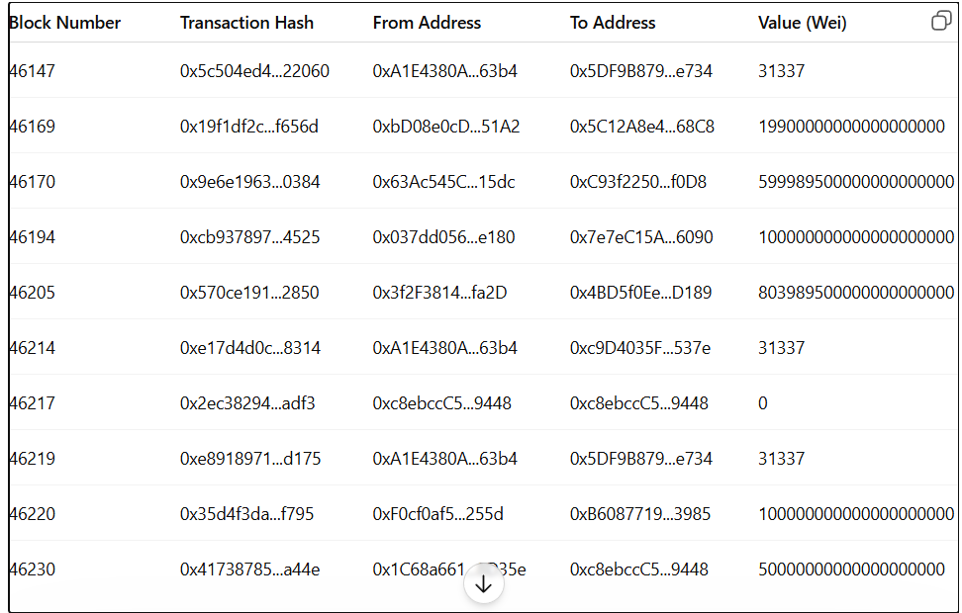
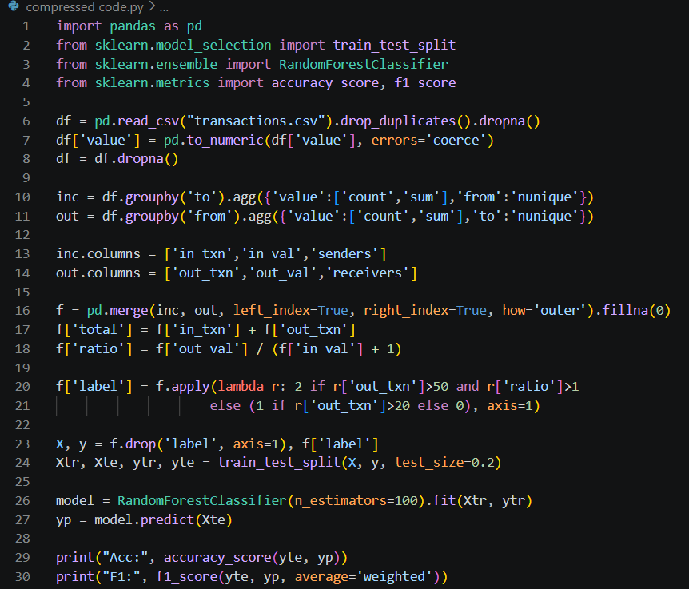

DECLARATION

I hereby certify that the work which is being presented in the project report entitled “Blockchain Forensics for Pig Butchering Scams” in partial fulfilment of requirement for the award of the degree of Bachelor of Engineering (Computer Science and Engineering) submitted in the department of Computer Science and Engineering at Chitkara University Institute of Engineering and Technology, Chitkara University, Punjab, India, is an authentic record of my own work carried out under the supervision of Dr. Gurpreet Singh. The matter presented in this project report has not been submitted in any other university/institute for the award of any degree.

Place: Rajpura Pratham Chhetri
Date: …11/05/2016… University Roll No…2210992075….

This is to certify that the above statement made by the candidate is correct to the best of my knowledge and belief.

Dr. Gurpreet Singh
Associate Professor and Placement Incharge
Department of Computer Science and Engineering
Chitkara University Institute of Engineering and Technology,
Chitkara University, Punjab, India

